############################# Source Code Management ################################

# Create Application repo in github

<https://github.com/anhtuanst1/sd4780_msa>

# Create Infrastructure repo in github

<https://github.com/anhtuanst1/sd4780_azure_infrastructure>

# Create Pipeline repo in github

<https://github.com/anhtuanst1/sd4780_azure_devops_ci_cd>

############################# Provision Azure Resource ################################

# Clone Infrastructure code and provision azure resouce using terraform (Resource Group, Virtual network, ACR, AKS)

Terraform init

Terraform plan

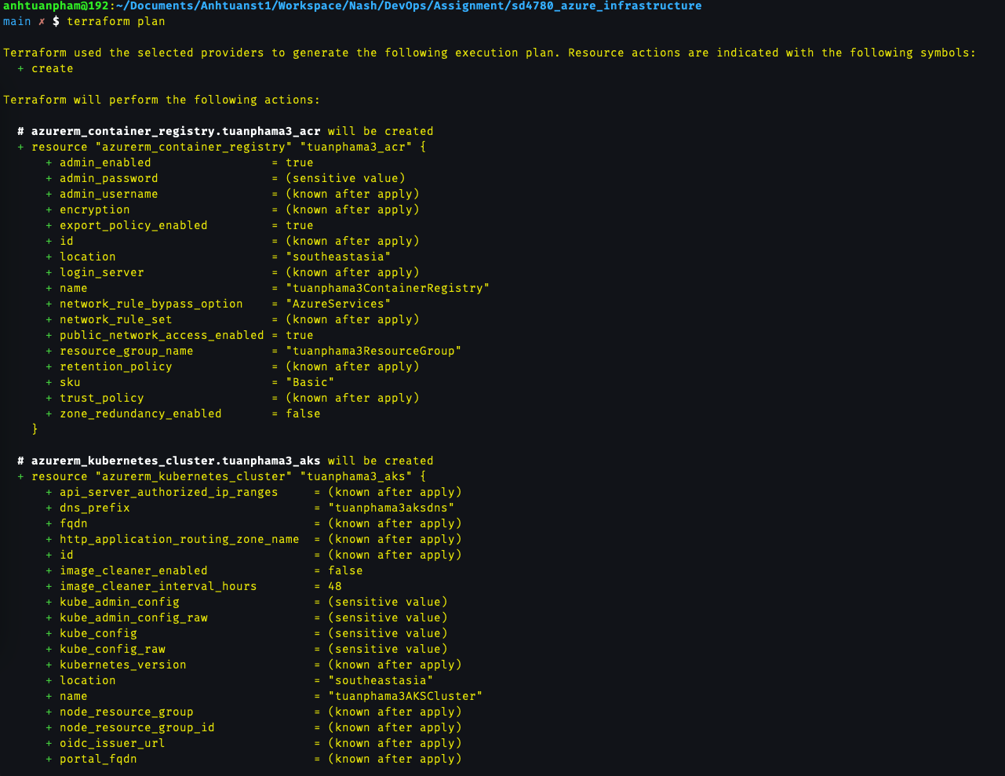

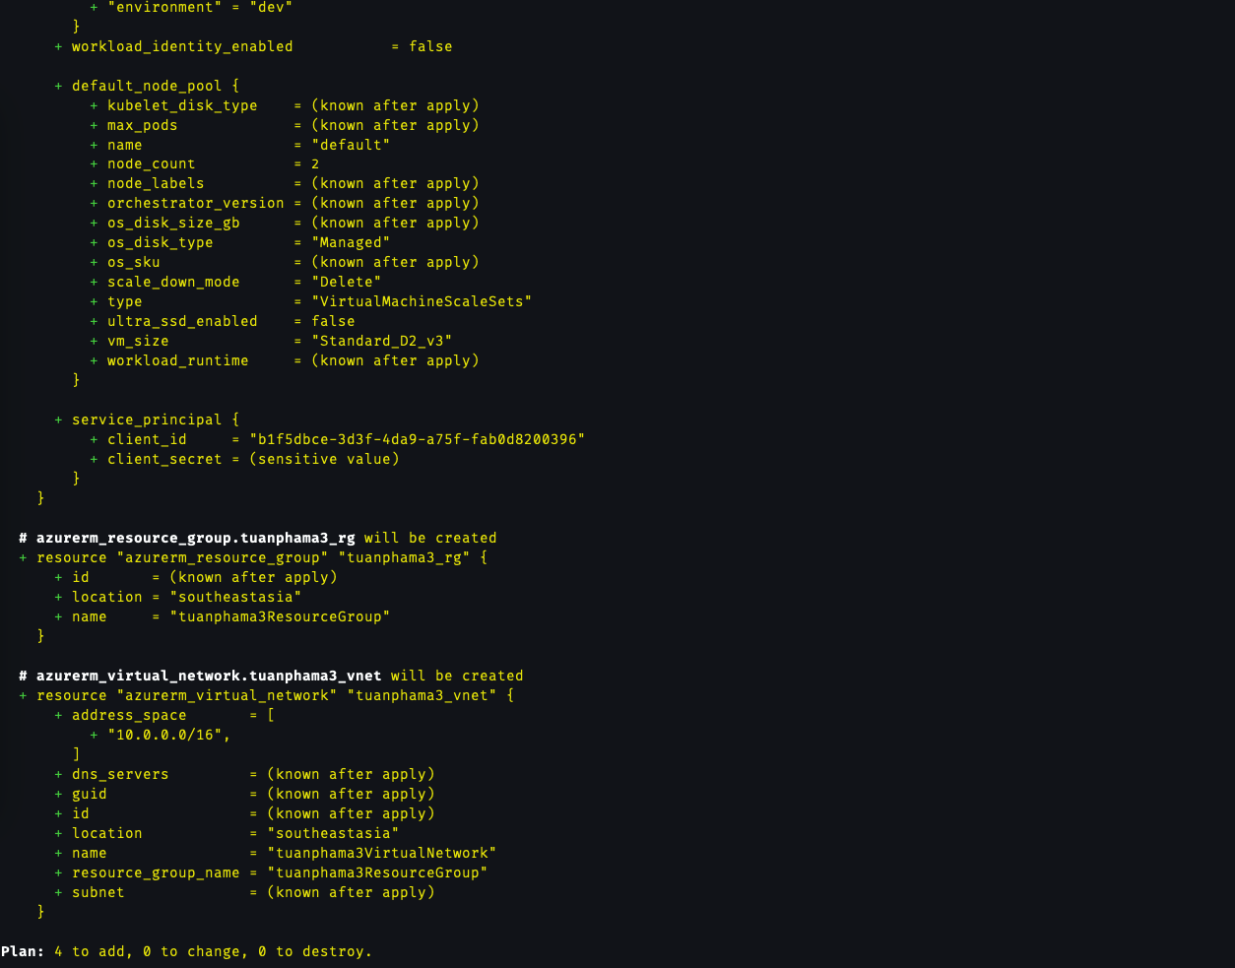

Terraform apply

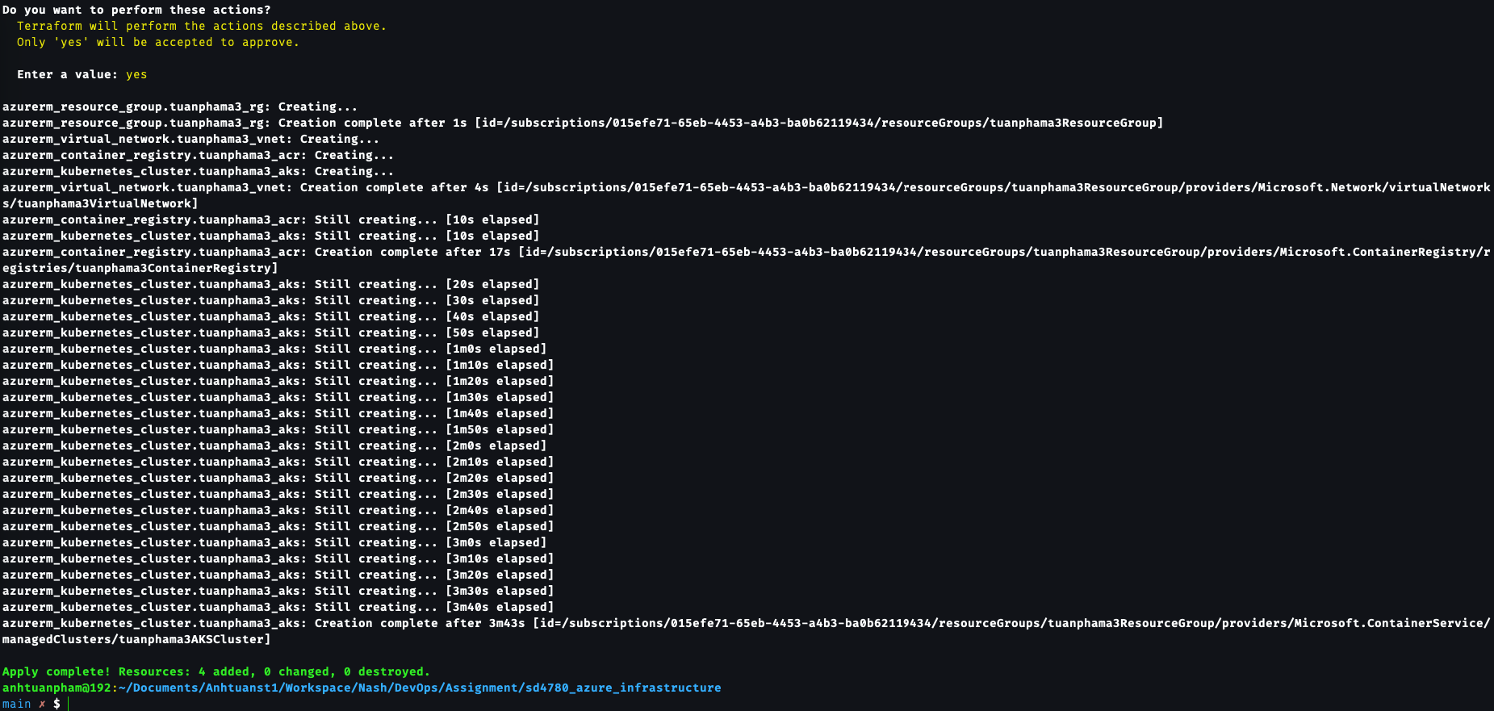

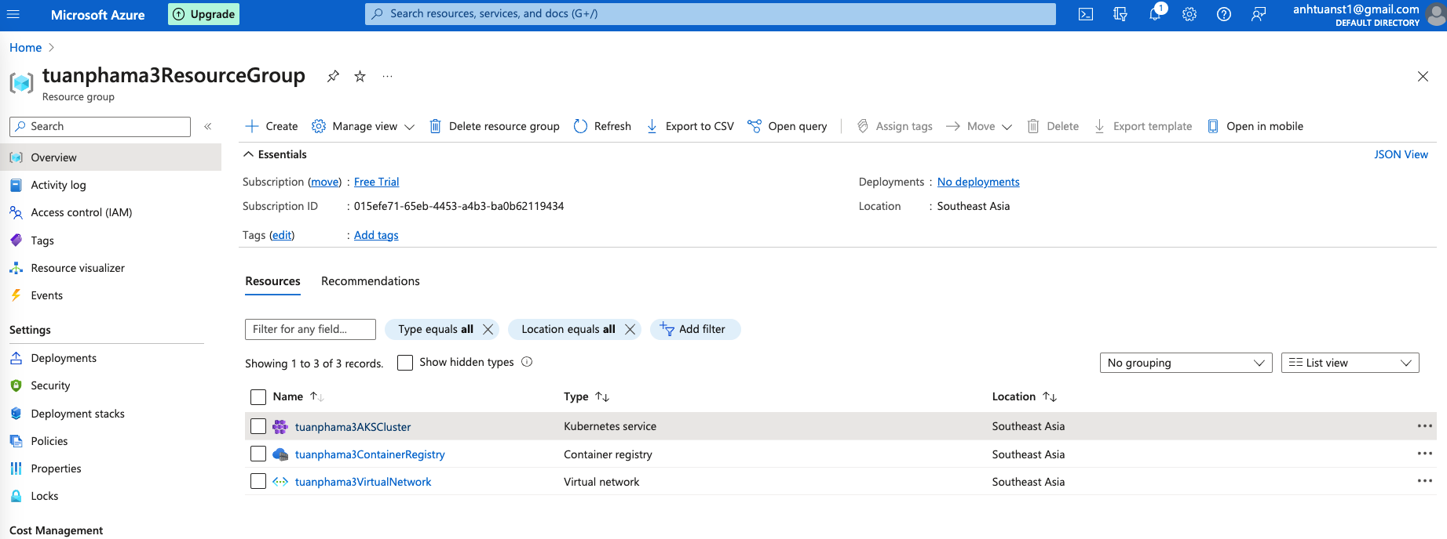

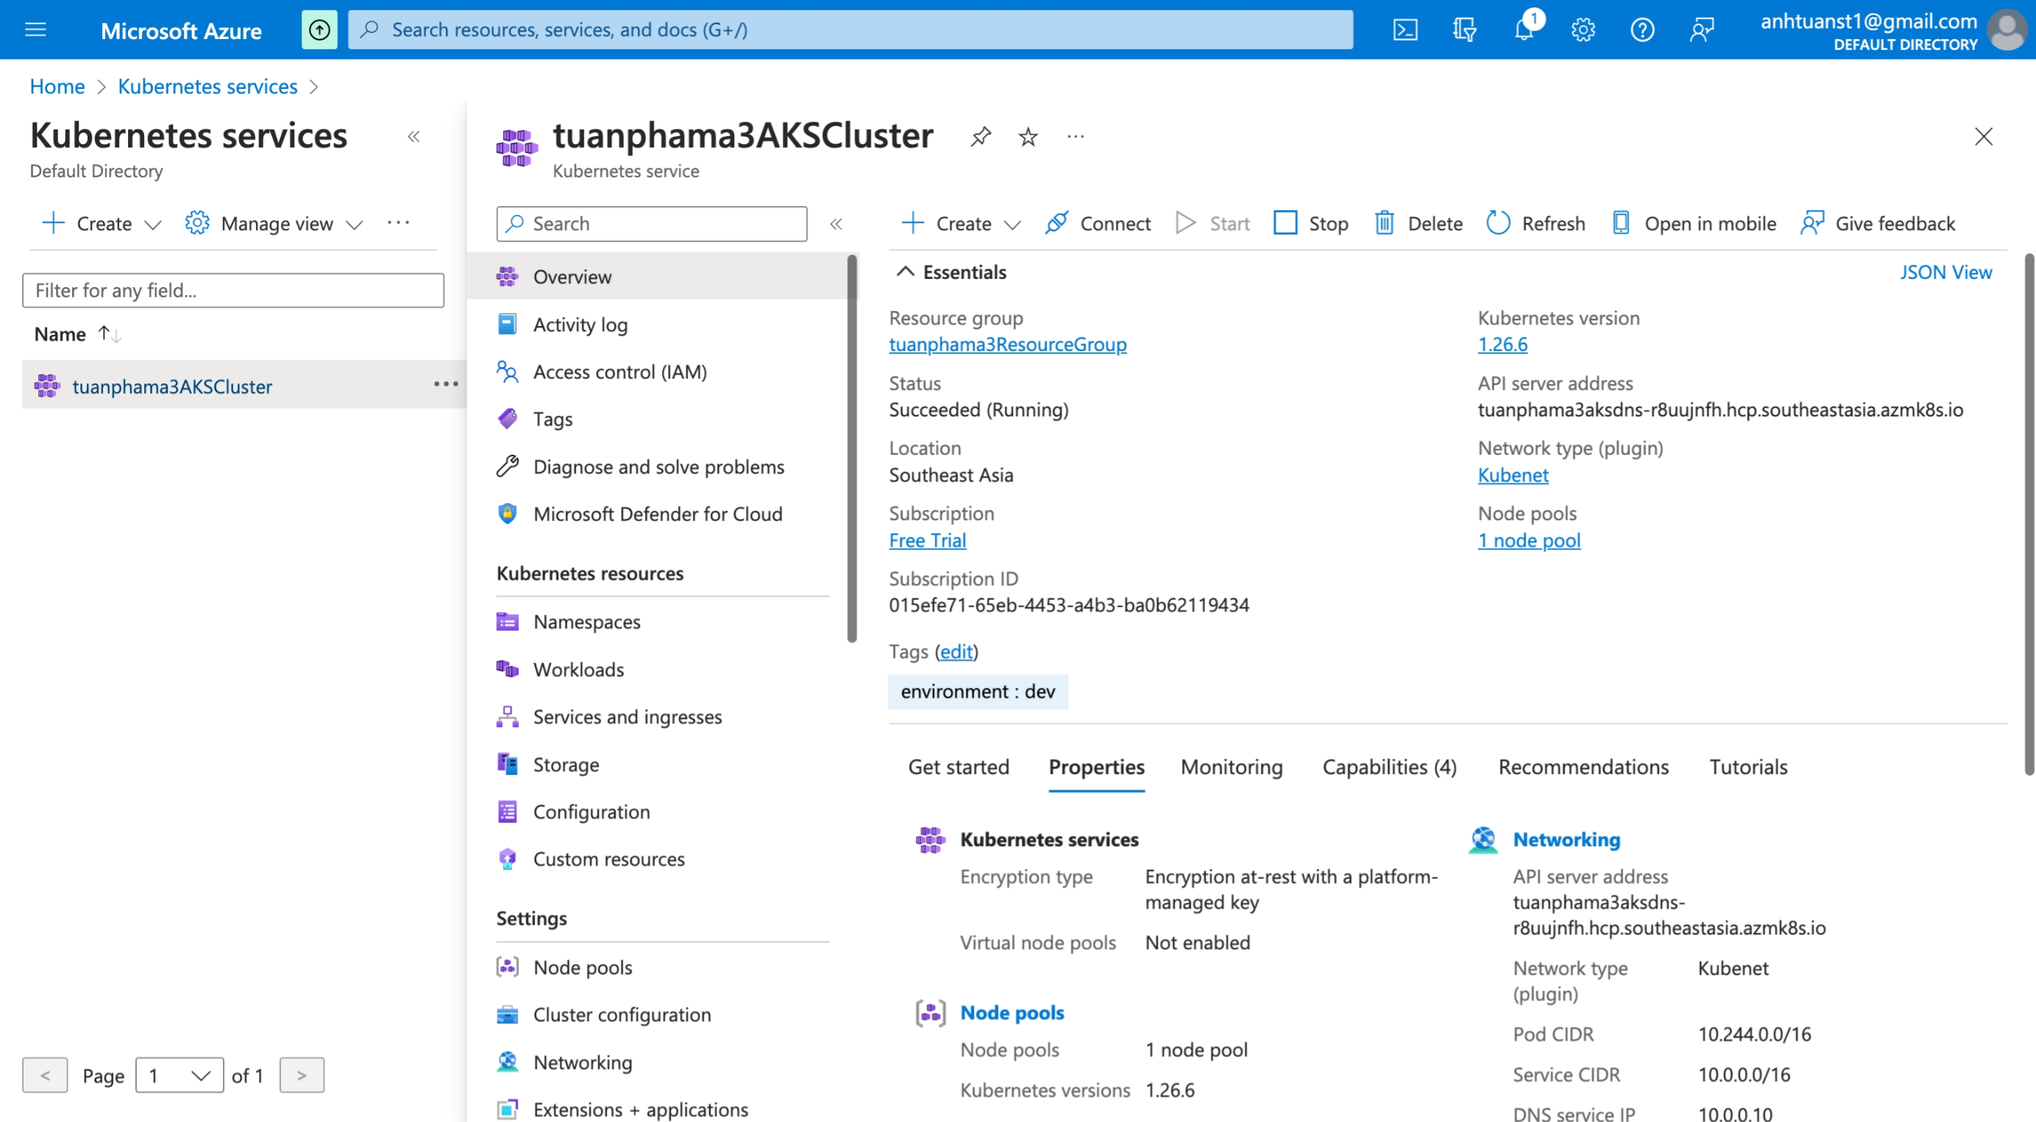

Test connect ACR (push docker images to ACR)

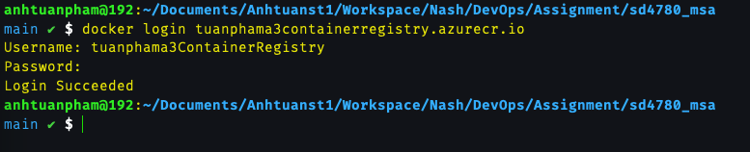

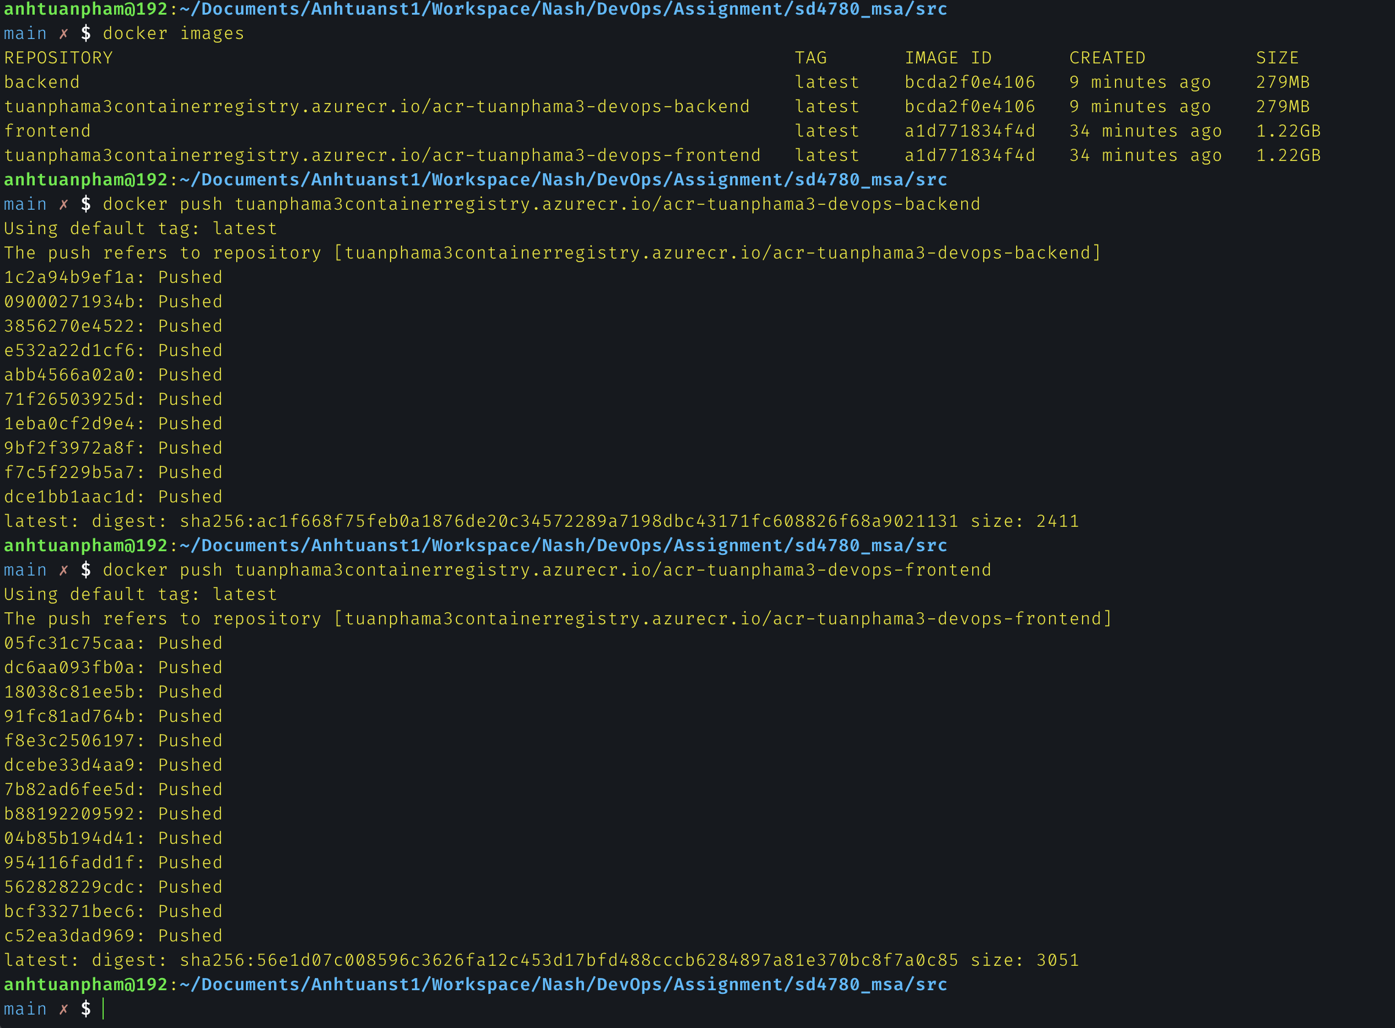

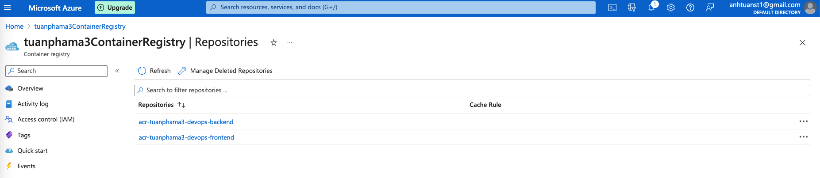

Github connection and Import Repository from Github

Import sd4780_azure_devops_ci_cd and sd4780_msa repos

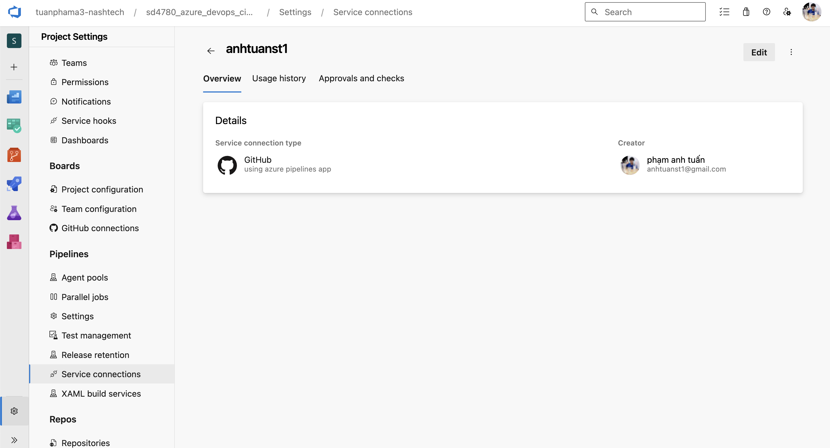

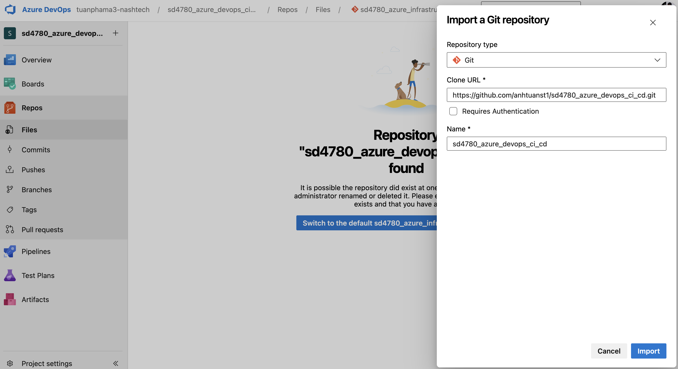

Create pipeline and config run pipeline from YAML file in repository

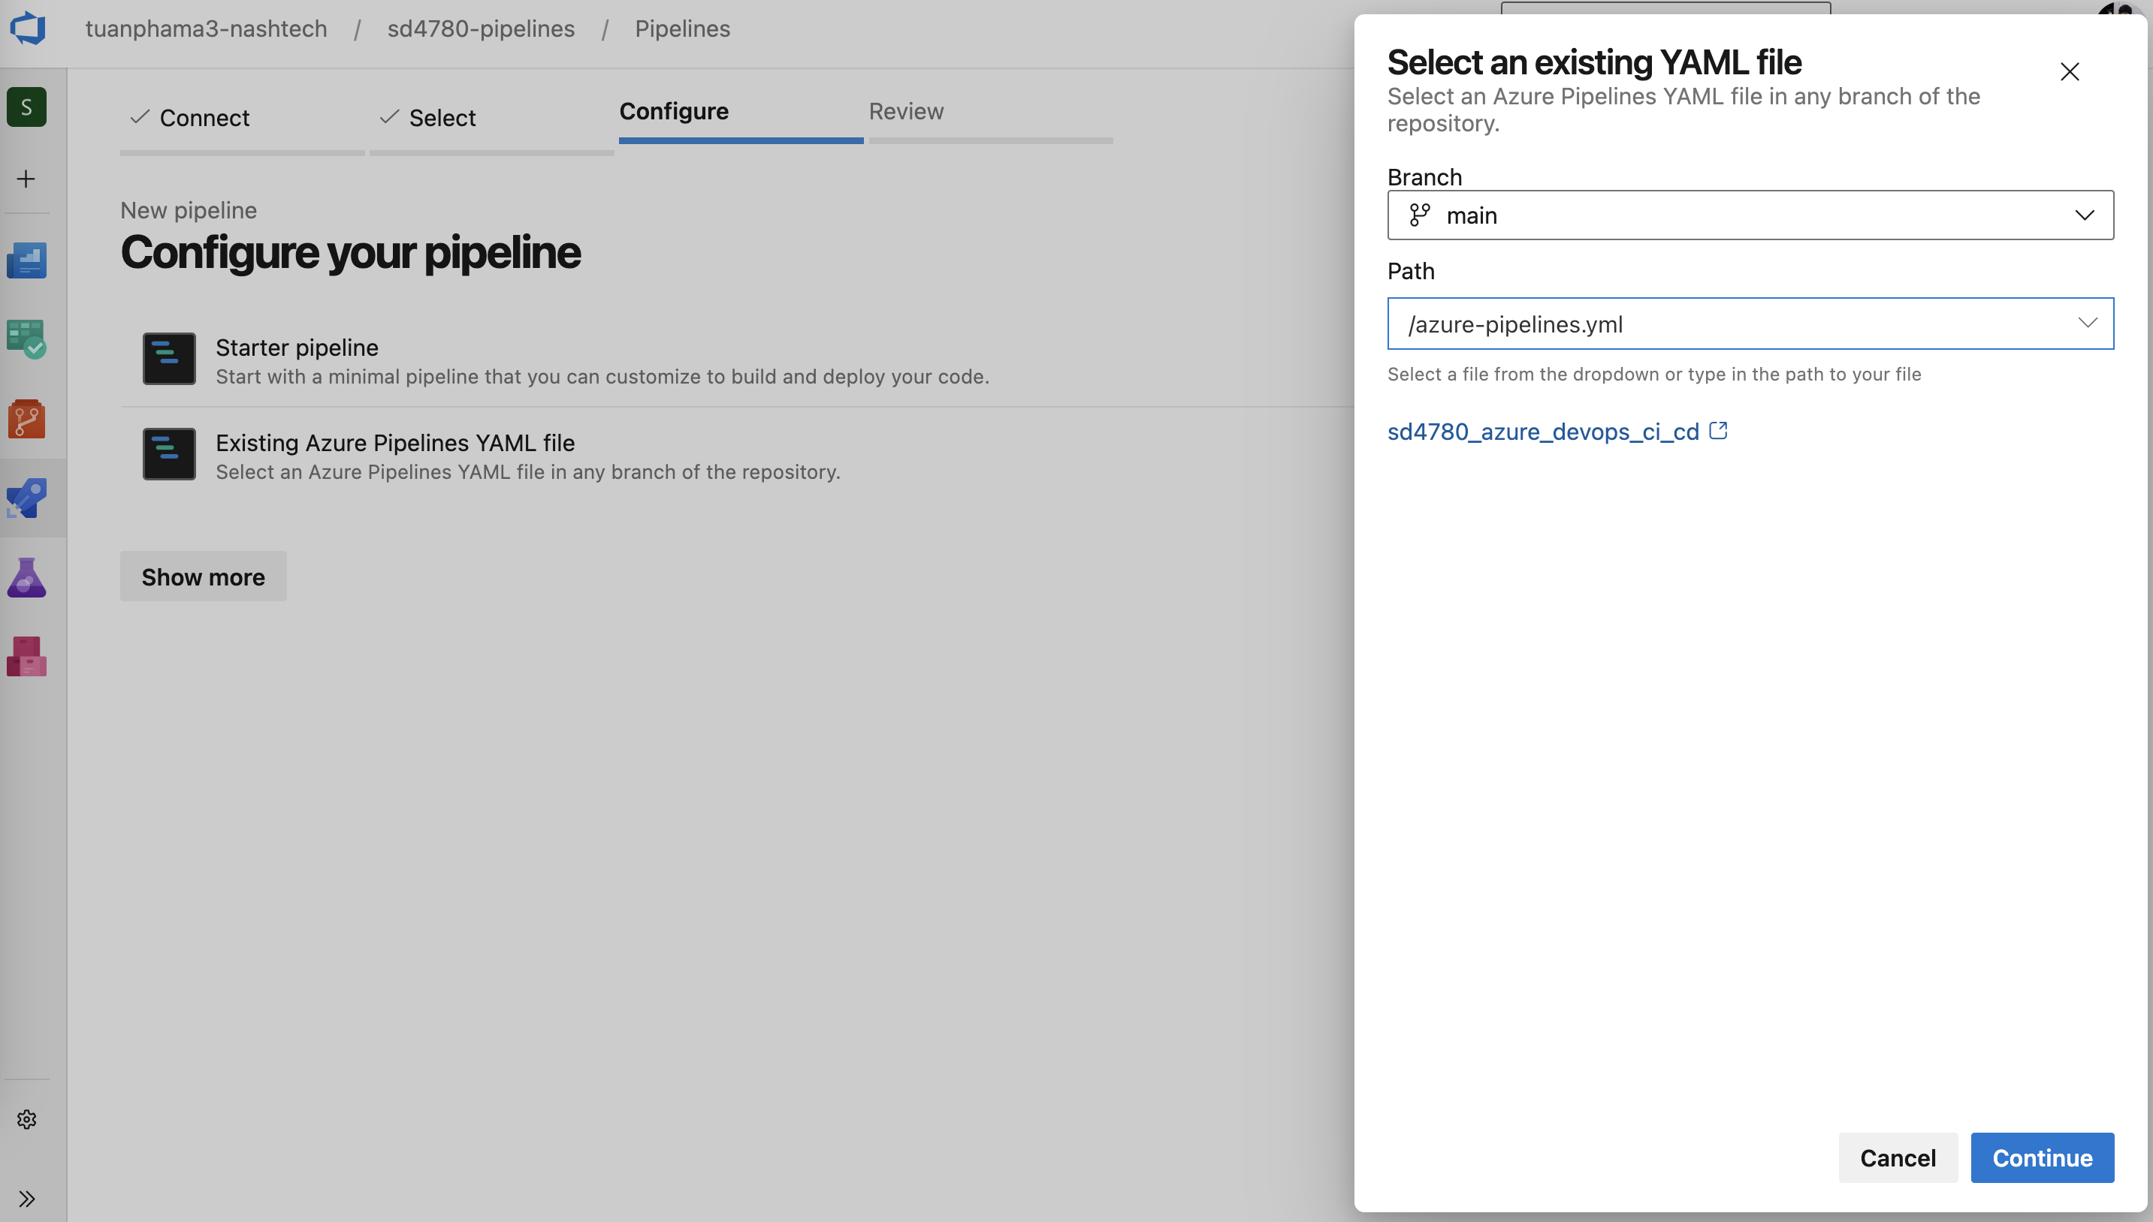

After push code to main brach in sd4780_msa repo

The pipeline build and push (CI) will

* install node
* npm install
* build images
* push images to ACR

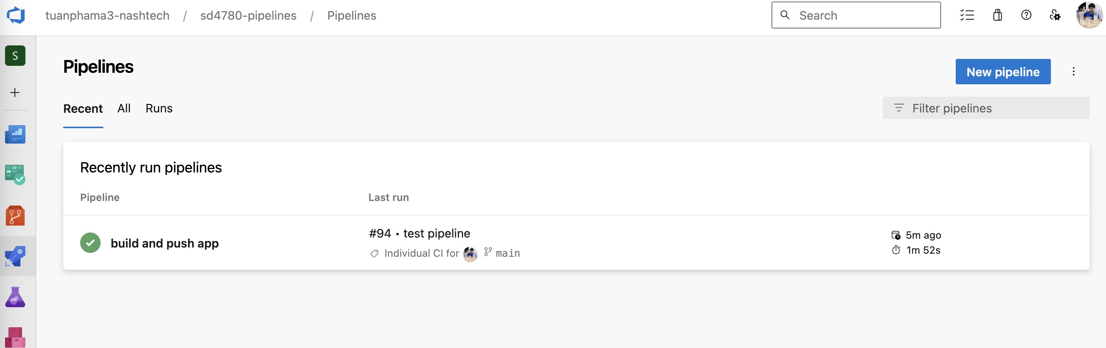

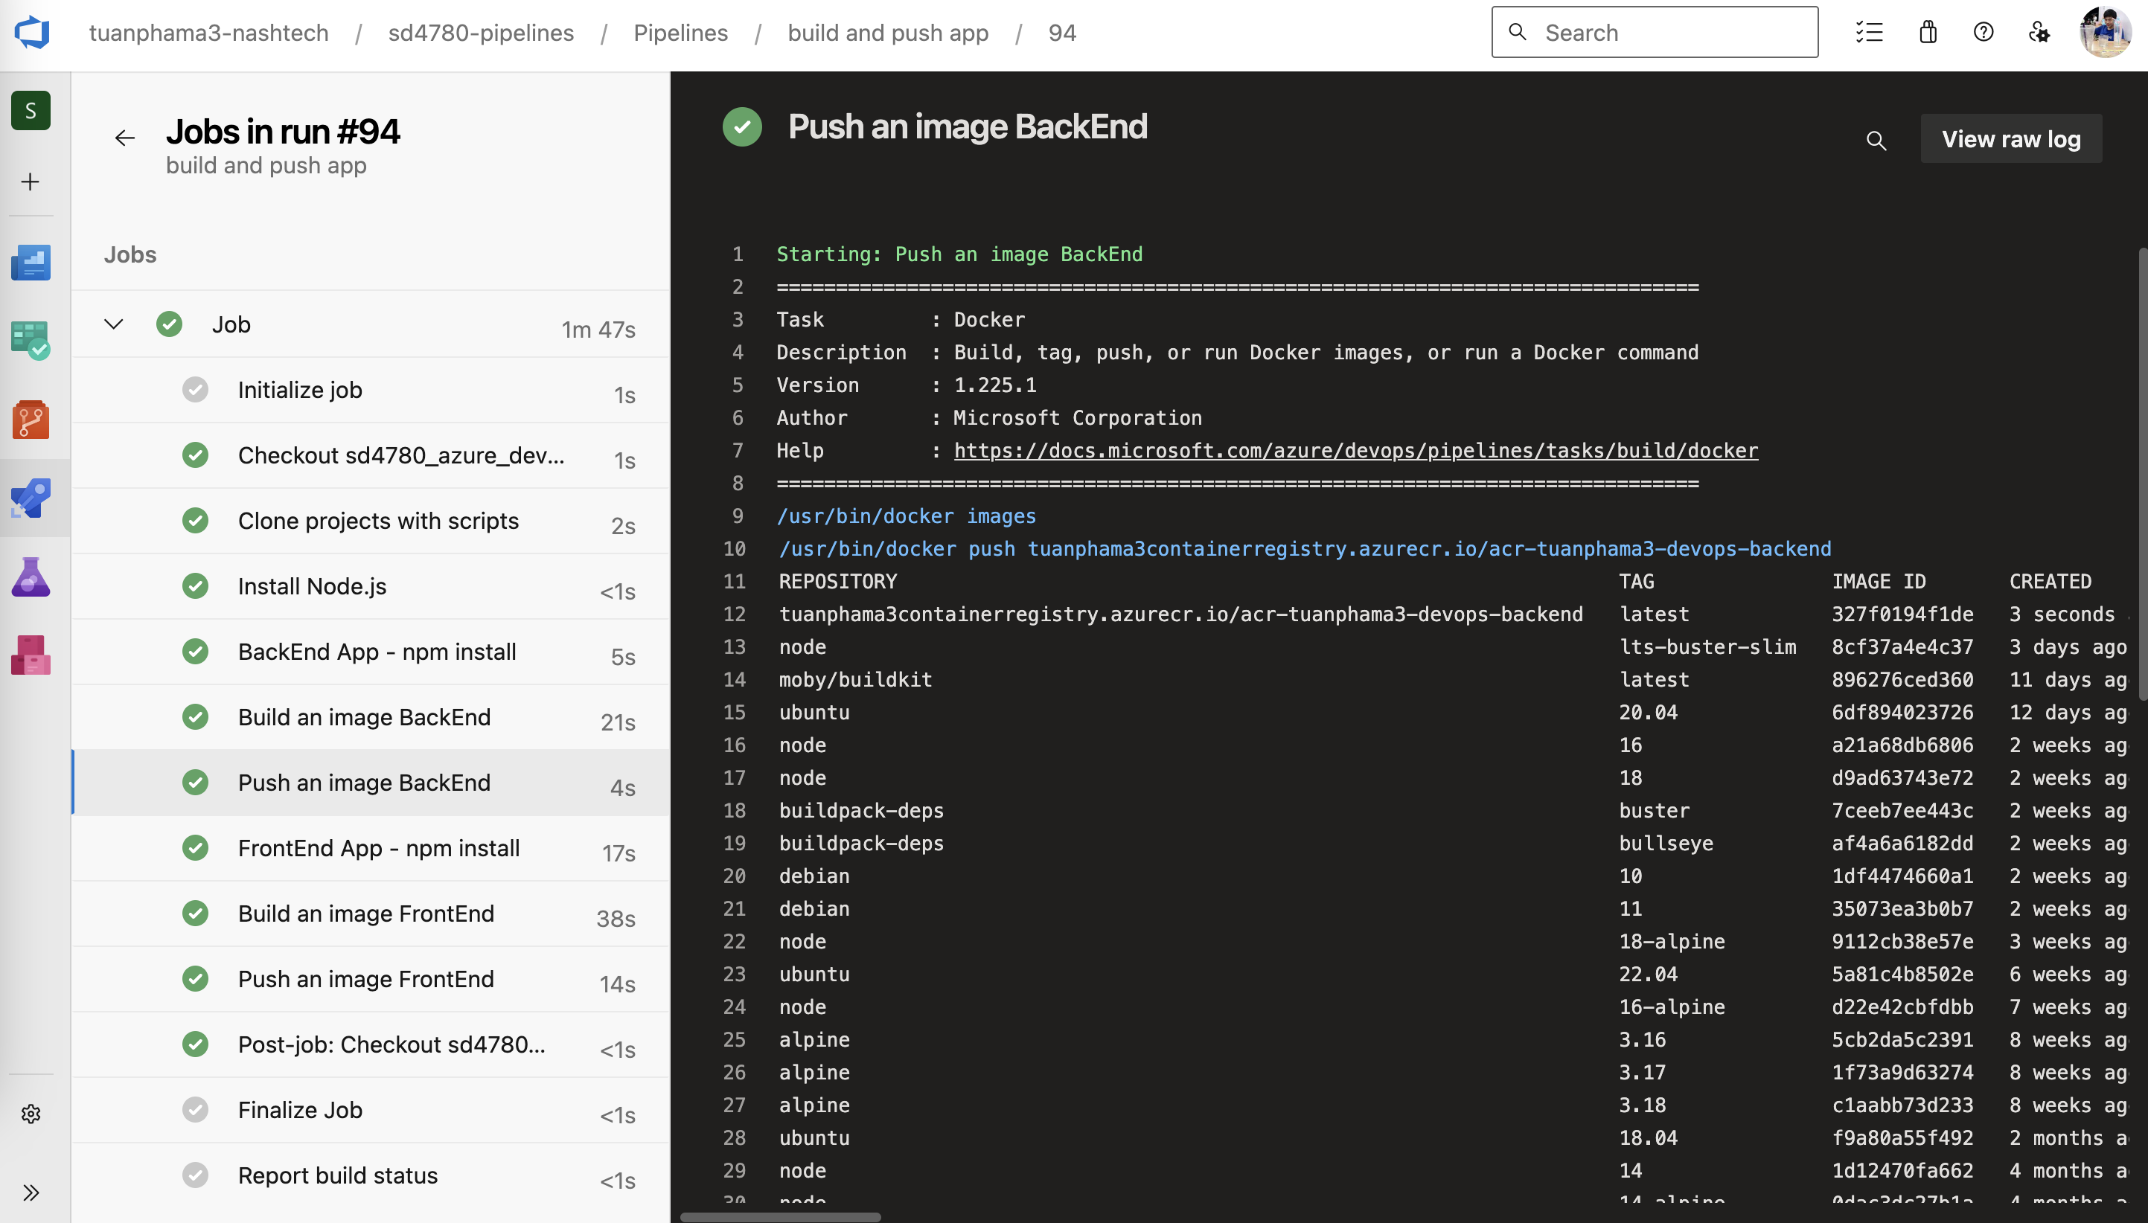

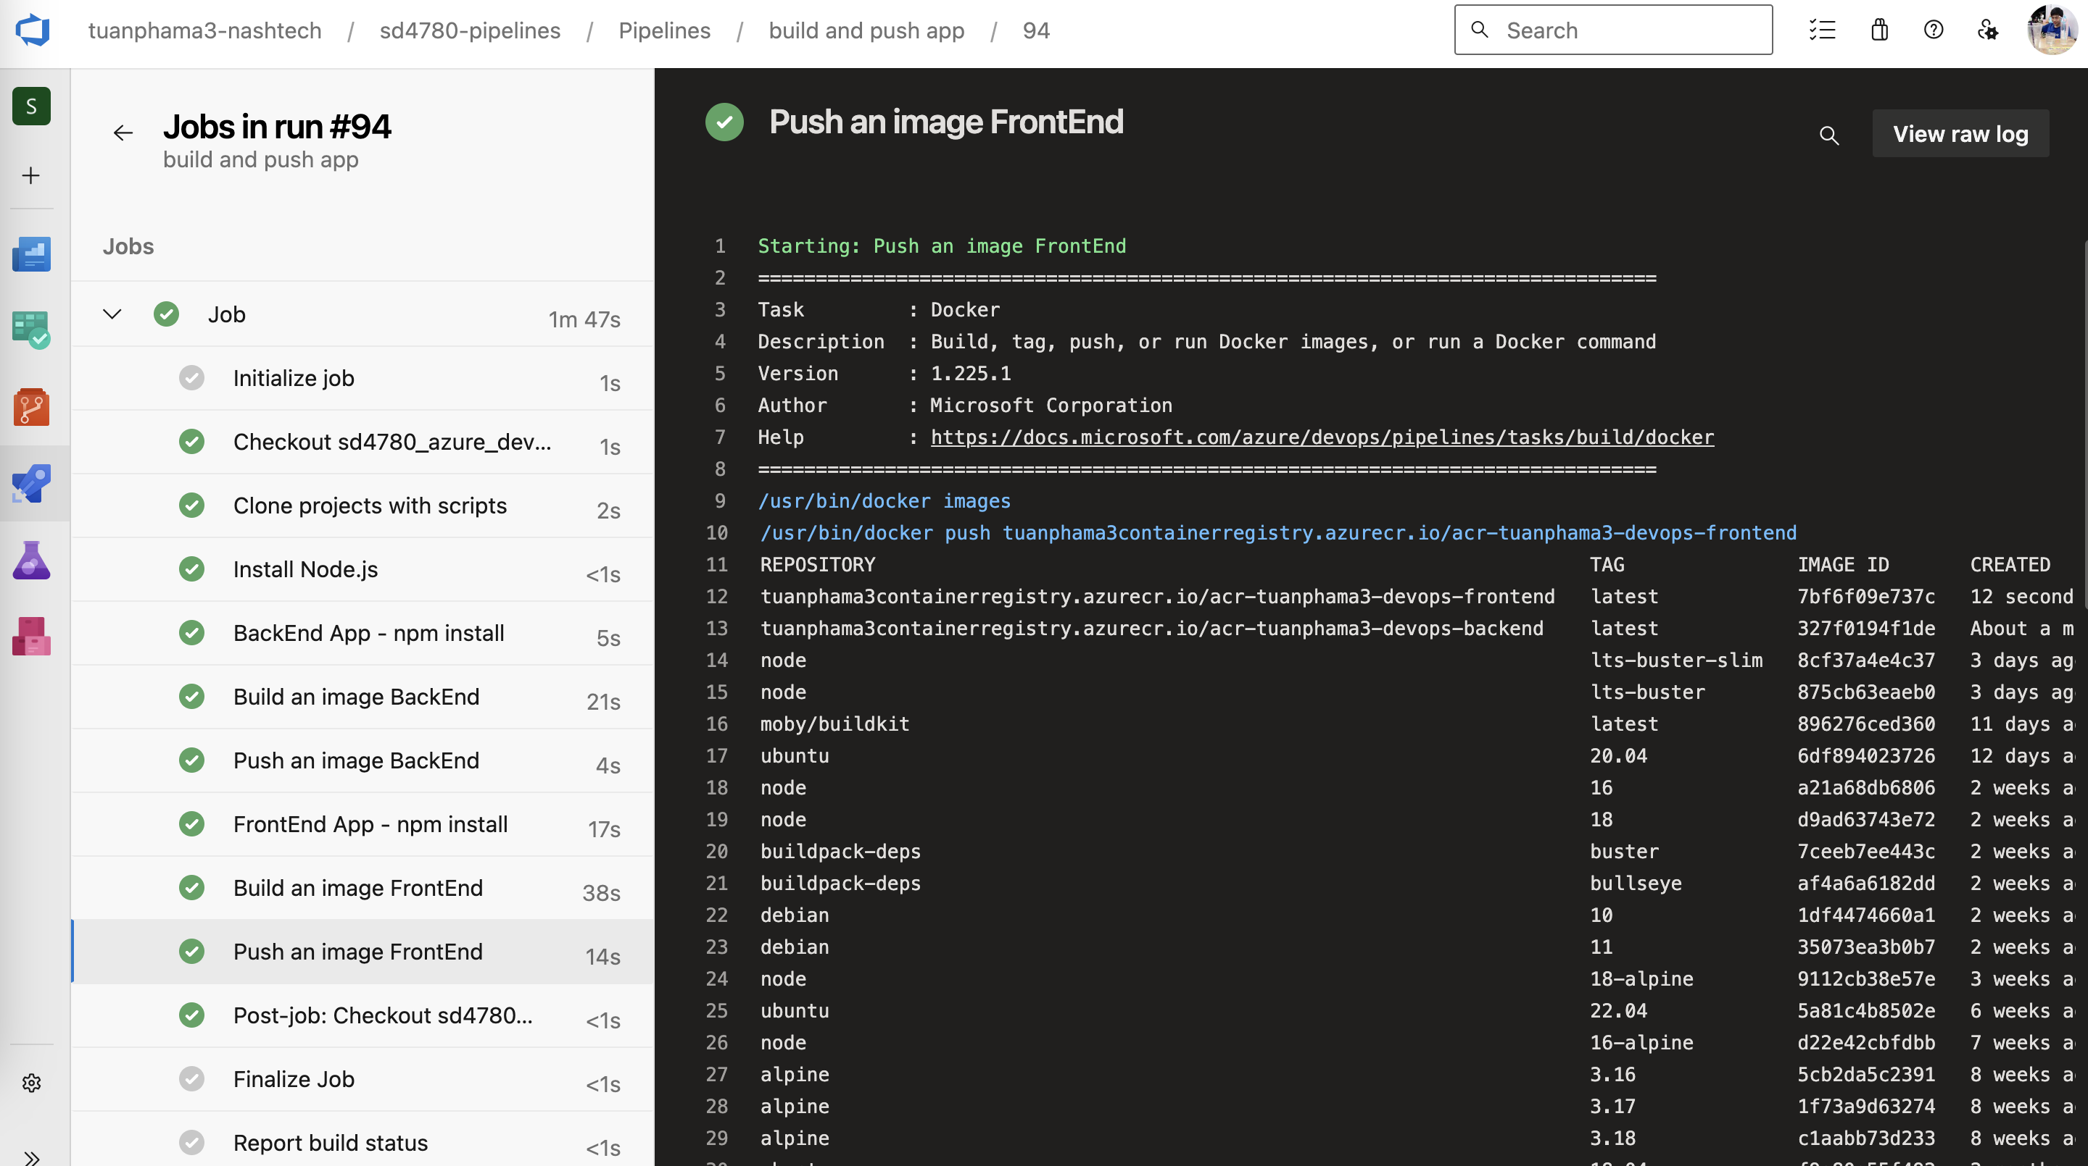

Install Helm and install nginx ingress controller in AKS

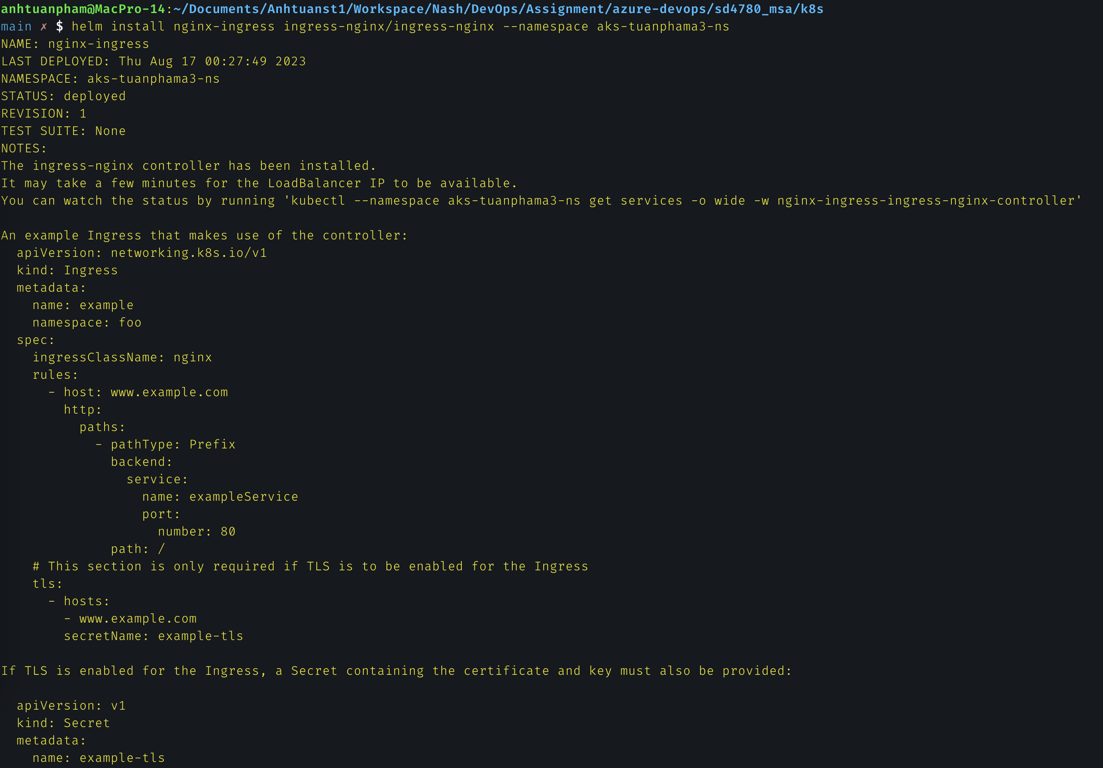

Run pipeline Deploy App

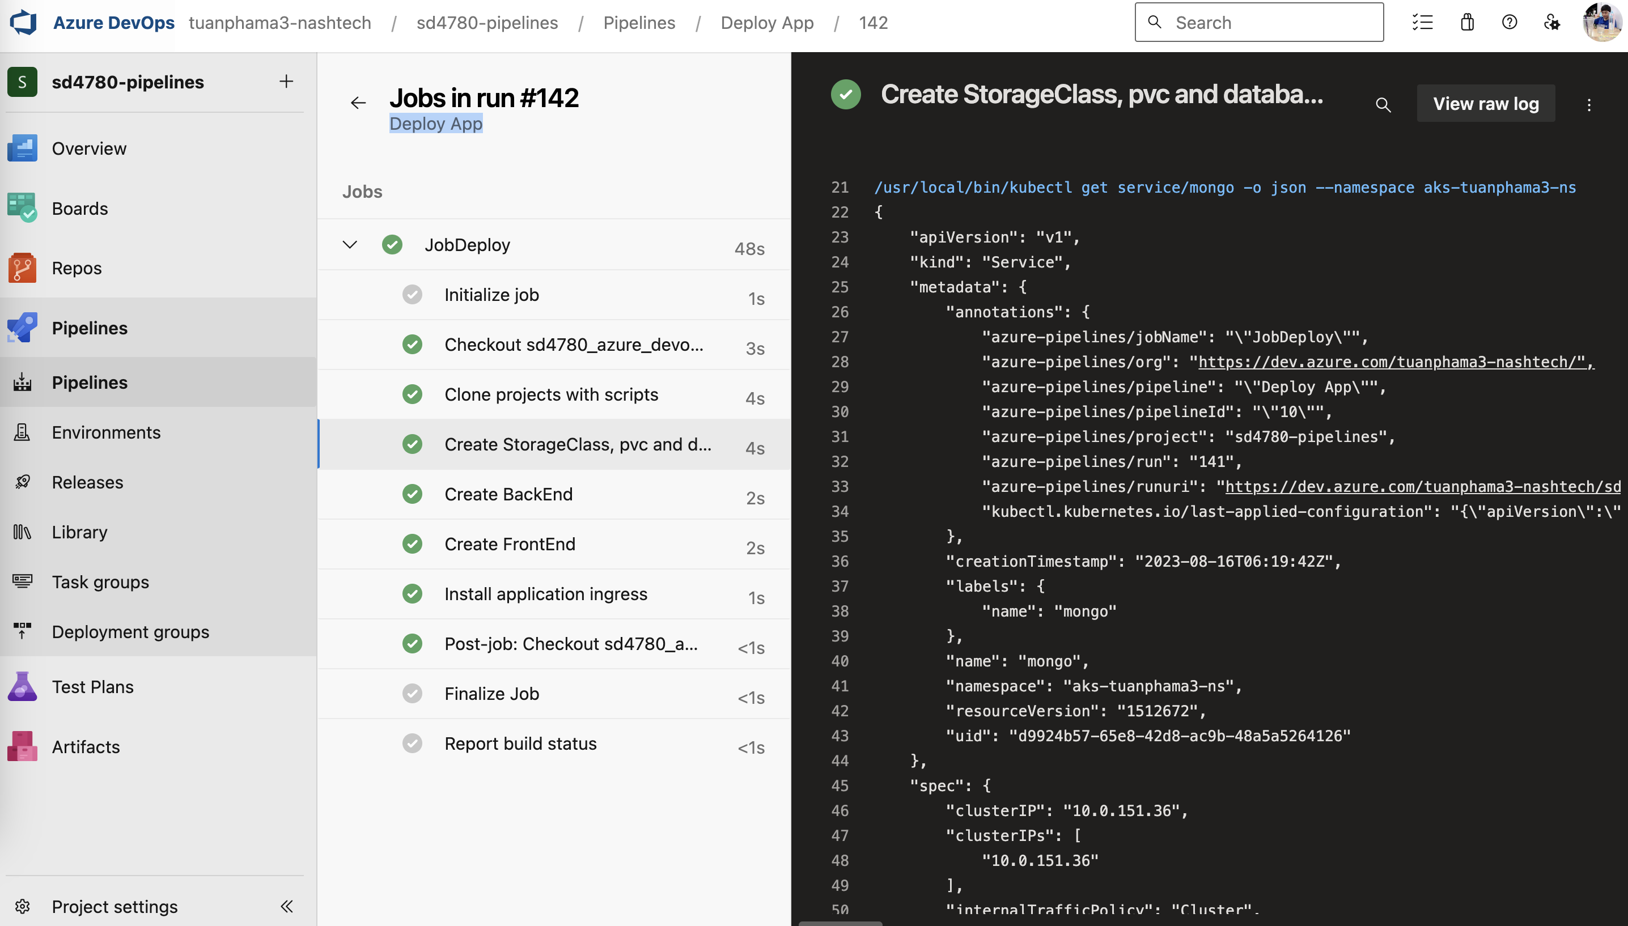  
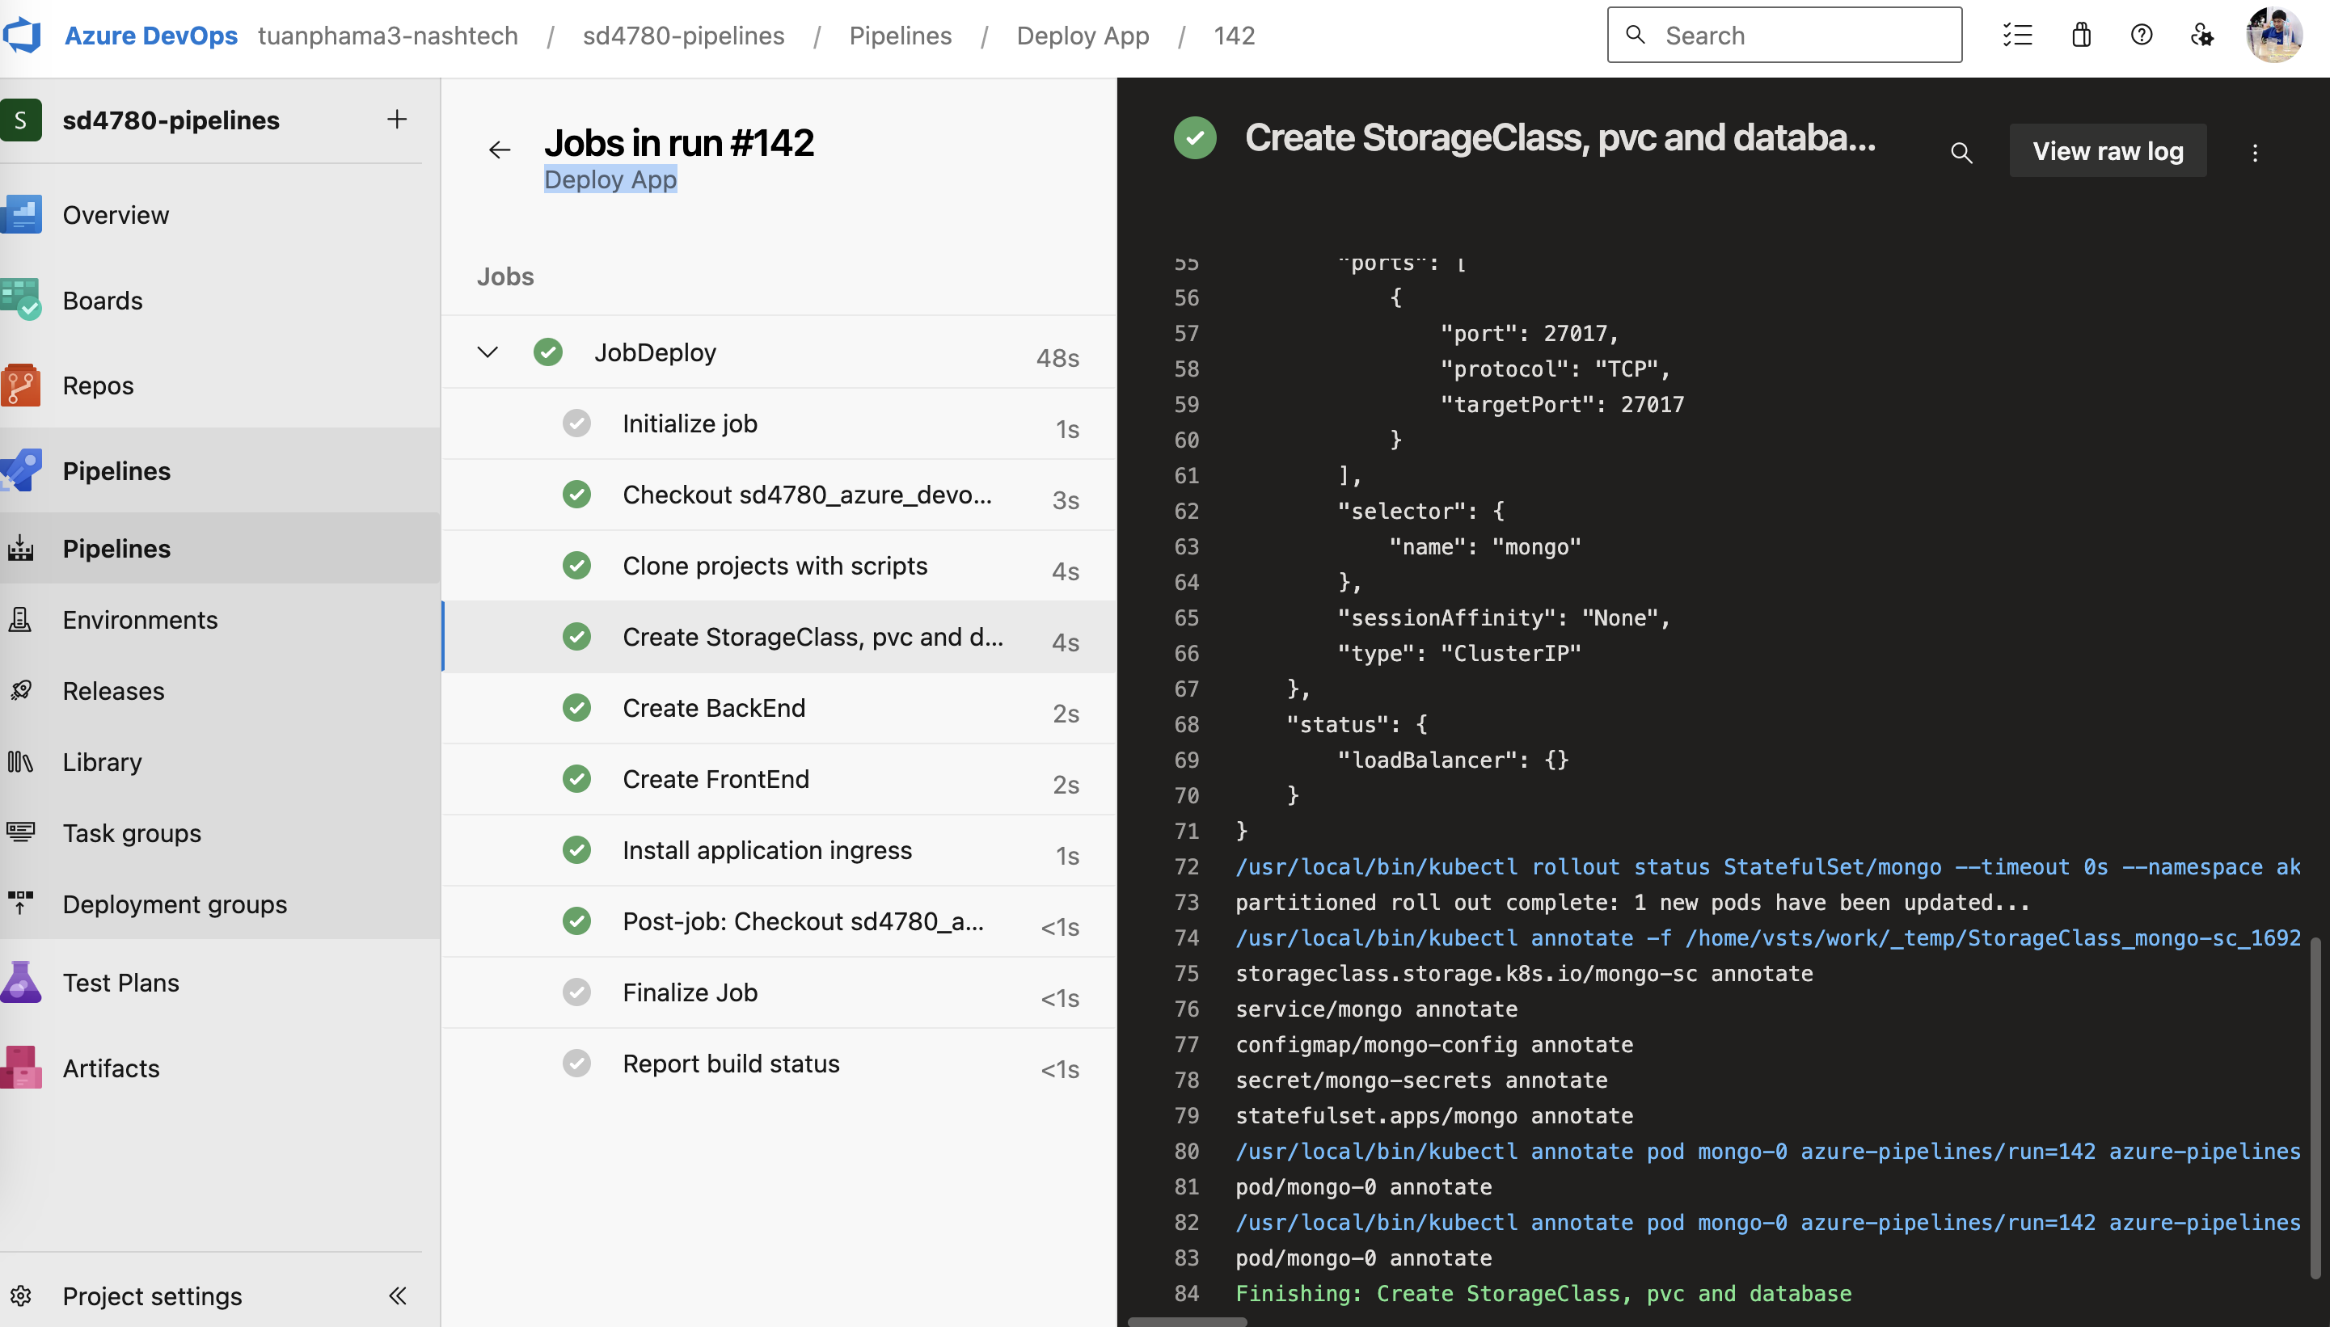

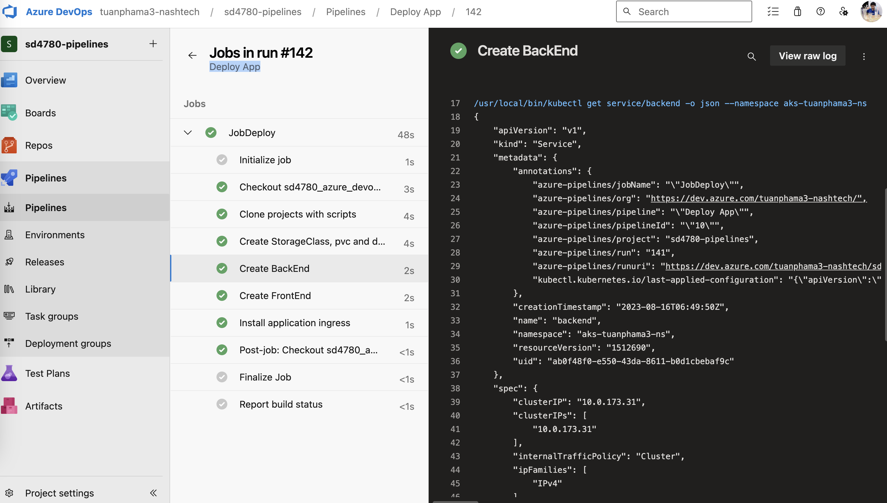

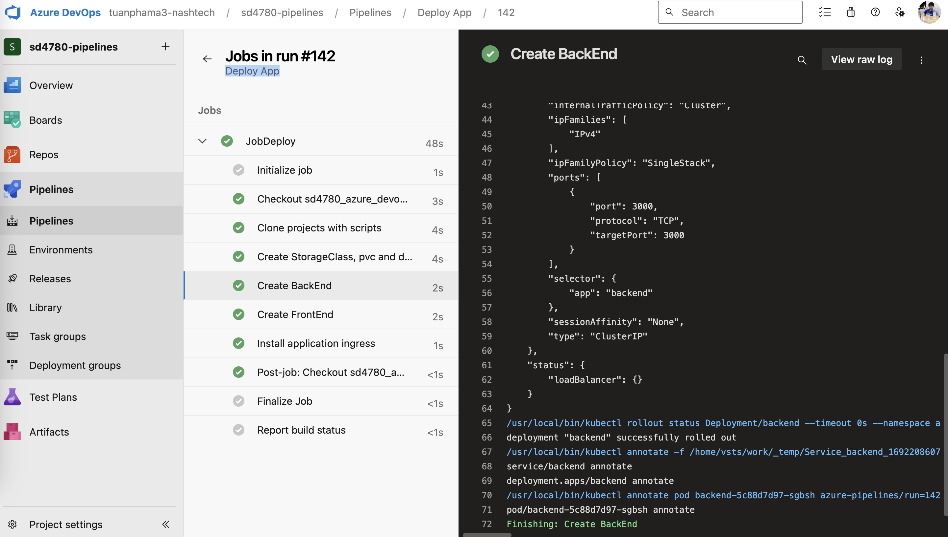

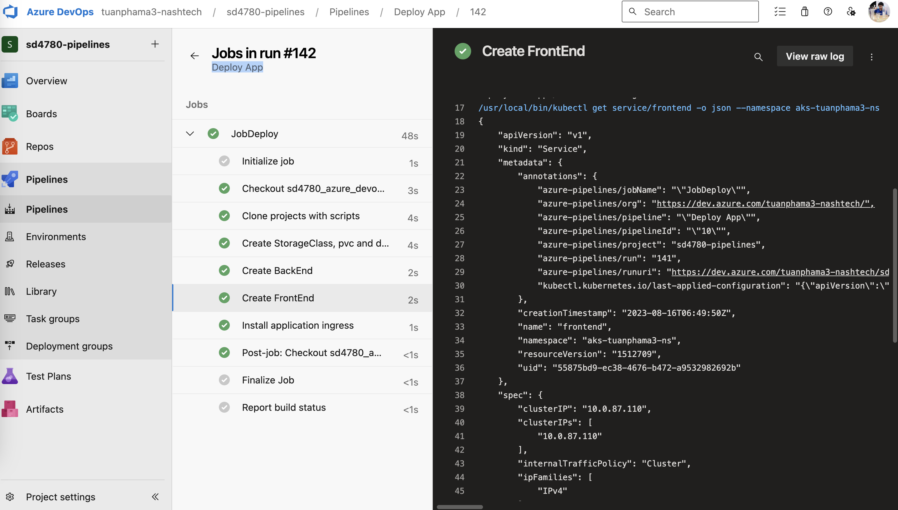

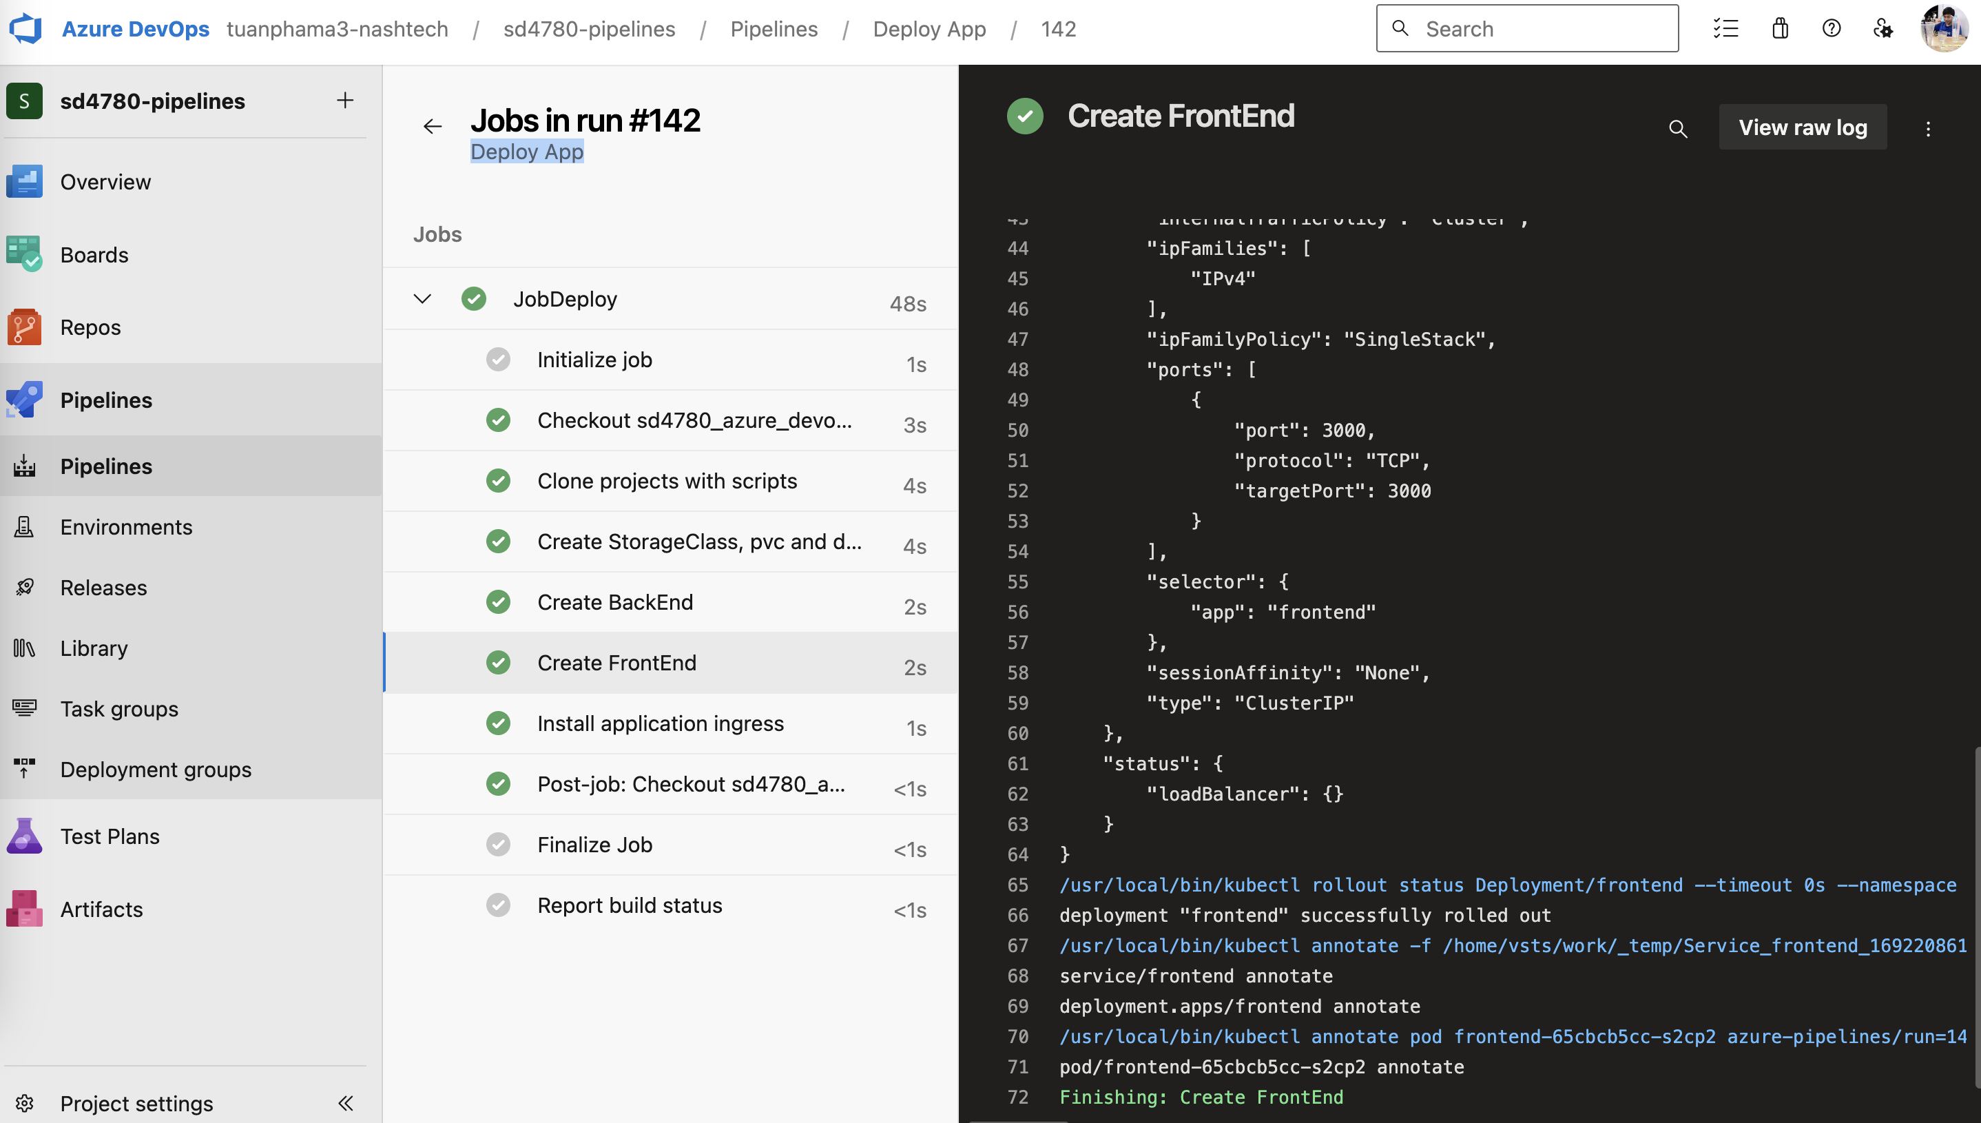

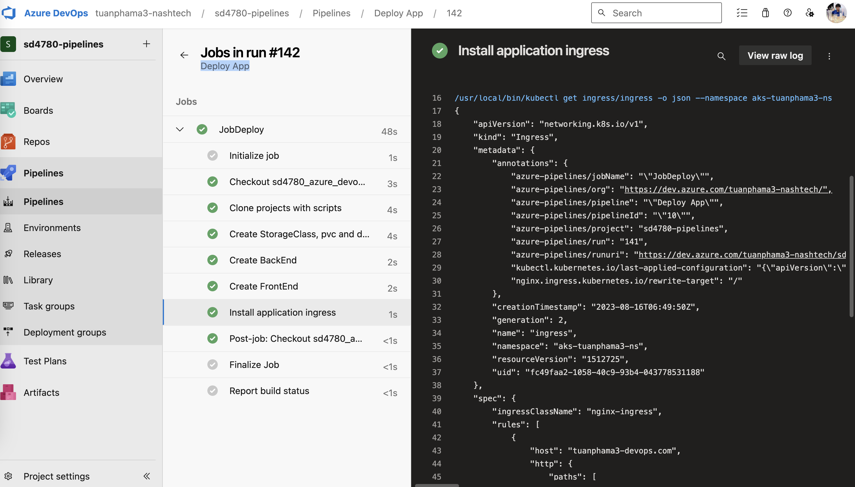

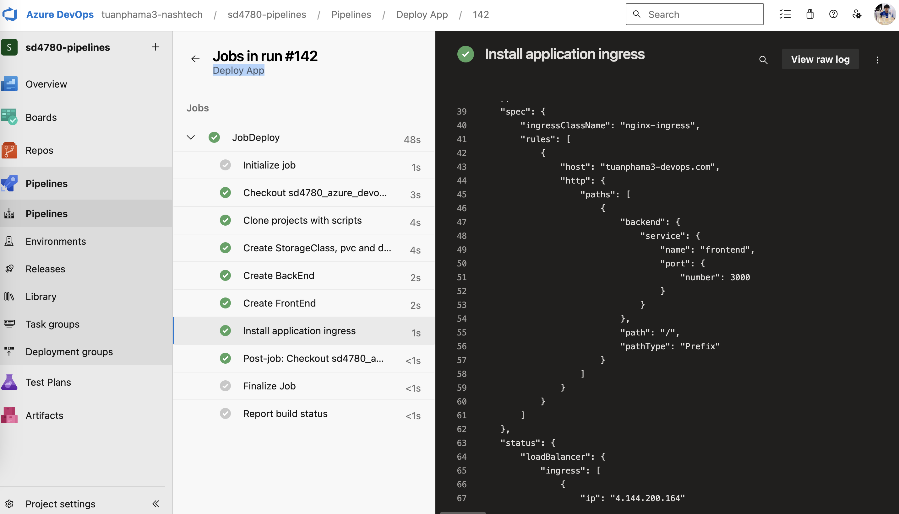

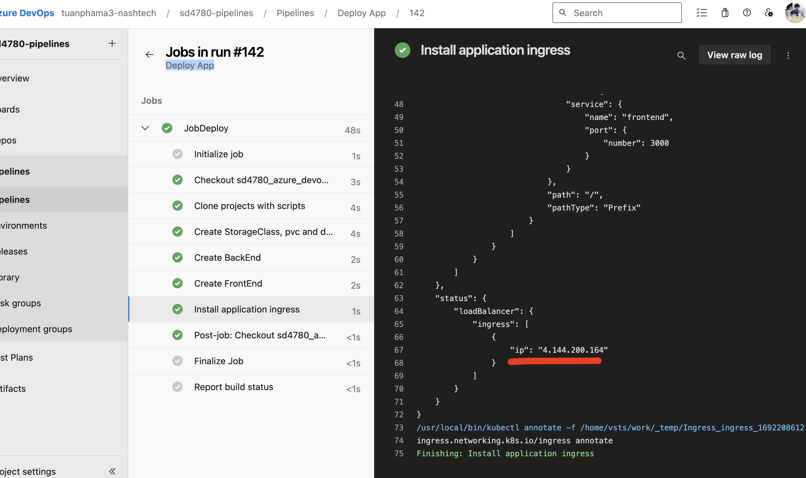



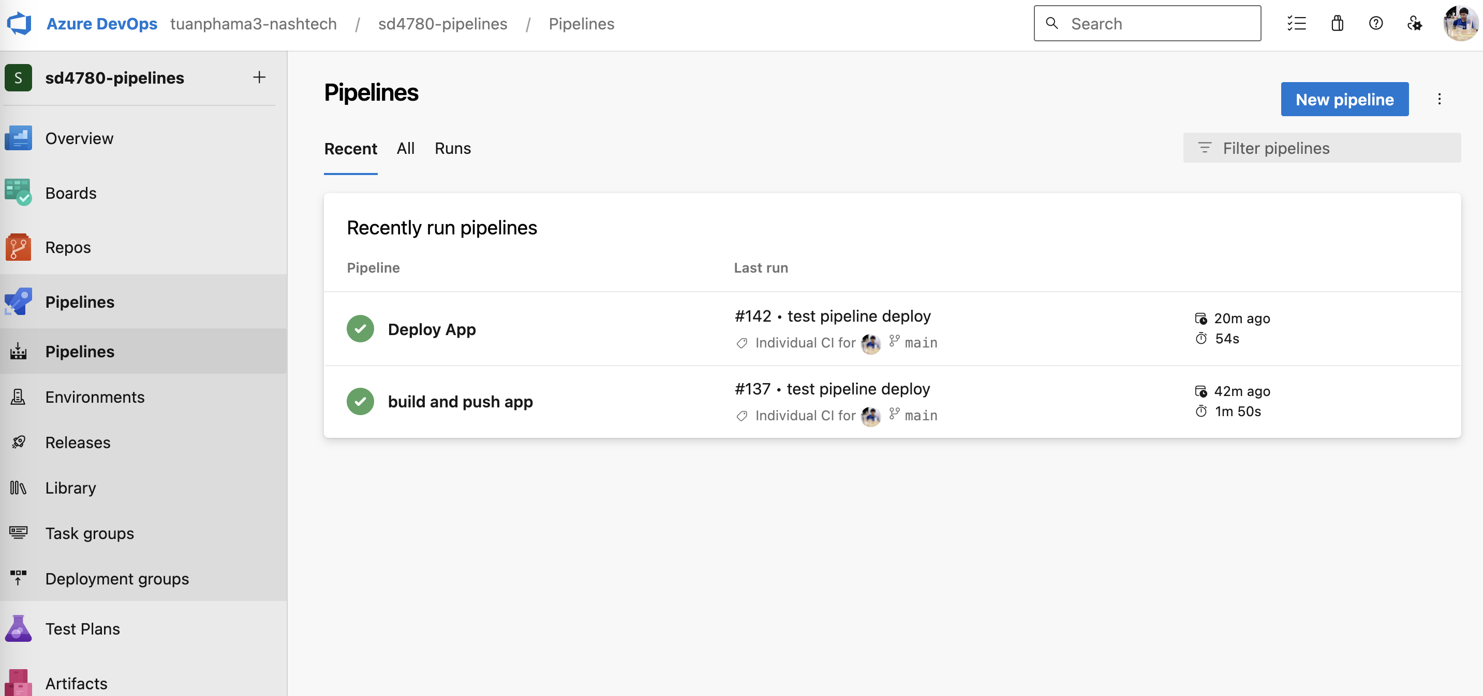

# Final Result

